**Capstone Project**

**IBM Data Science Professional Certificate**

**Opening a Japanese Restaurant in Toronto, Canada**

**Introduction**

Restaurant business is considered to be stable if the demographics requirements are met. Especially, crowded metropolis areas require restaurants for busy people who work in the city and prefer dining-out than cooking at home. For our studies we are interested in Japanese cuisine as it is the favorite of big audiences, starting from vegans to people of any age.

Location-wise Toronto is the most-populated city in Canada with over 6 million people in 2020 with the highest median salary of 123,000 CAD across the country. Thus it is believed that restaurant business goes well around the city. This study is going to analyze the best possible location for our Japanese Restaurant in Toronto, Canada so potential stakeholders could have great success and consistent profit.

**Business Problem**

The objective of this project is to analyze and select the best locations in the city of Toronto, Canada to open a new Japanese restaurant. Utilizing data science methodology and instruments such as data analysis and data visualization project aims to provide solutions for our business problem: Where in Toronto, Canada should the investor open a Japanese Restaurant.

**Data Description**

To proceed with studies we will be using the following data:

1. Toronto, Canada data containing neighborhoods and boroughs
2. Latitude and Longitude coordinates of these neighborhoods for plotting the map
3. Venue data, namely restaurants data of Toronto

**Data Source**

Toronto data source for neighborhoods and boroughs will be obtained from Wikipedia and wrangled with python pandas library. Further, we will retrieve geographical coordinates (latitude, longitude) from the website: <http://cocl.us/Geospatial_data> provided by IBM.

Additionally, we are going to use Foursquare API to get venue data for the neighborhoods. Foursquare is one of the largest database for location data with over 100 million places. Foursquare API provides different categories of the venue data, particularly we are interested in restaurant data to find the solution to our business problem.

**Methodology**

Collect the data from sources. Clean and process the data with Python libraries as numpy and pandas. Using Foursquare API, locate all venues filtering by Japanese Restaurants. Factors such as Ranking and Likes will be counted to sort the data. Additionally, we are going to visualize Python graphic libraries.

**Results**

1. As we can see from below chart Downtown Toronto has the highest number of Japanese Restaurants followed by North York and West Toronto:

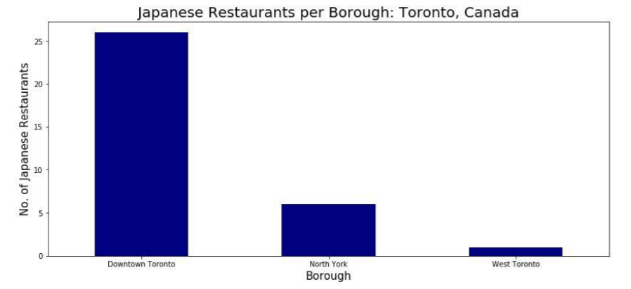

1. Subsequently average rating of Japanese Restaurants for each Borough chart. As we can see Downtown Toronto and West Toronto has highest ratings for Japanese cuisine:

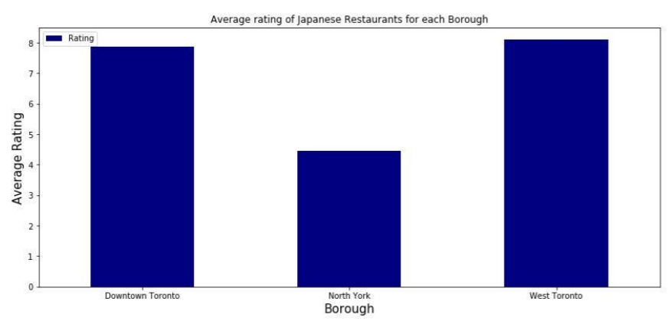

1. Map of Toronto with highest rated Japanese Restaurants:

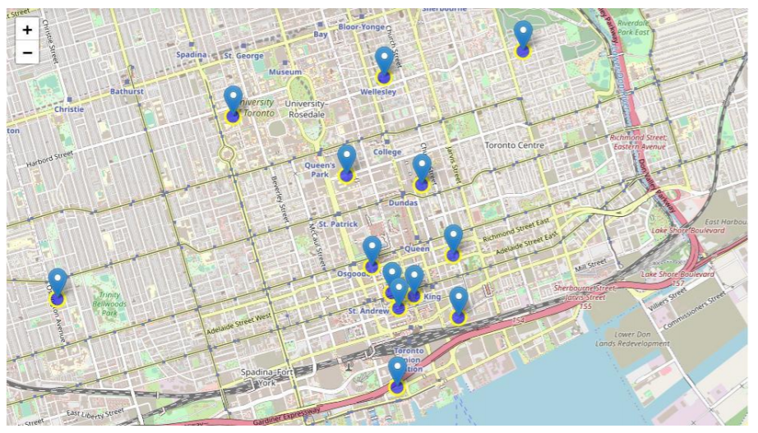

* Downtown Toronto has highest number of Japanese Restaurants compared to other Boroughs
* Downtown Toronto has highest average rating for the Japanese Restaurants
* Another highest average rating has in West Toronto
* However, number of
* Restaurants are few

**Discussion**

Based on the results of our analysis Downtown and West of Toronto are the best locations for Japanese cuisine in Toronto, Canada. However, West Toronto is more promising location with fewer competitors. Other locations are excluded during our initial analysis due to lower ratings.

**Conclusion**

We have answered our question suggesting West Toronto the best location to invest into new Japanese Restaurant in the area. The findings of this is applicable to real life. Improvements and additional criterion are suggested to apply for better results